Deploying Maven WebApp from Jenkins to Tomcat on Another EC2 Instance

Step 1 create two instance for Jenkins and tomcat and install the application on that respective

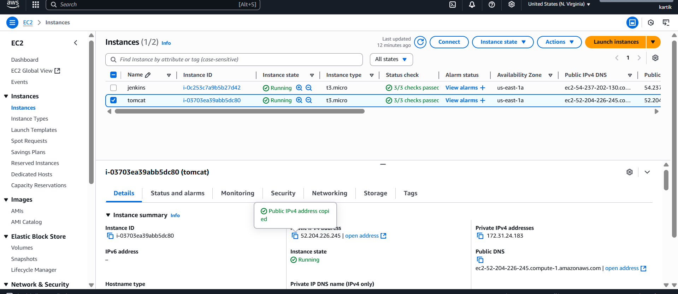

Step – 2 Start the Jenkins application and configure it by adding two plugins Maven and Publish over ssh

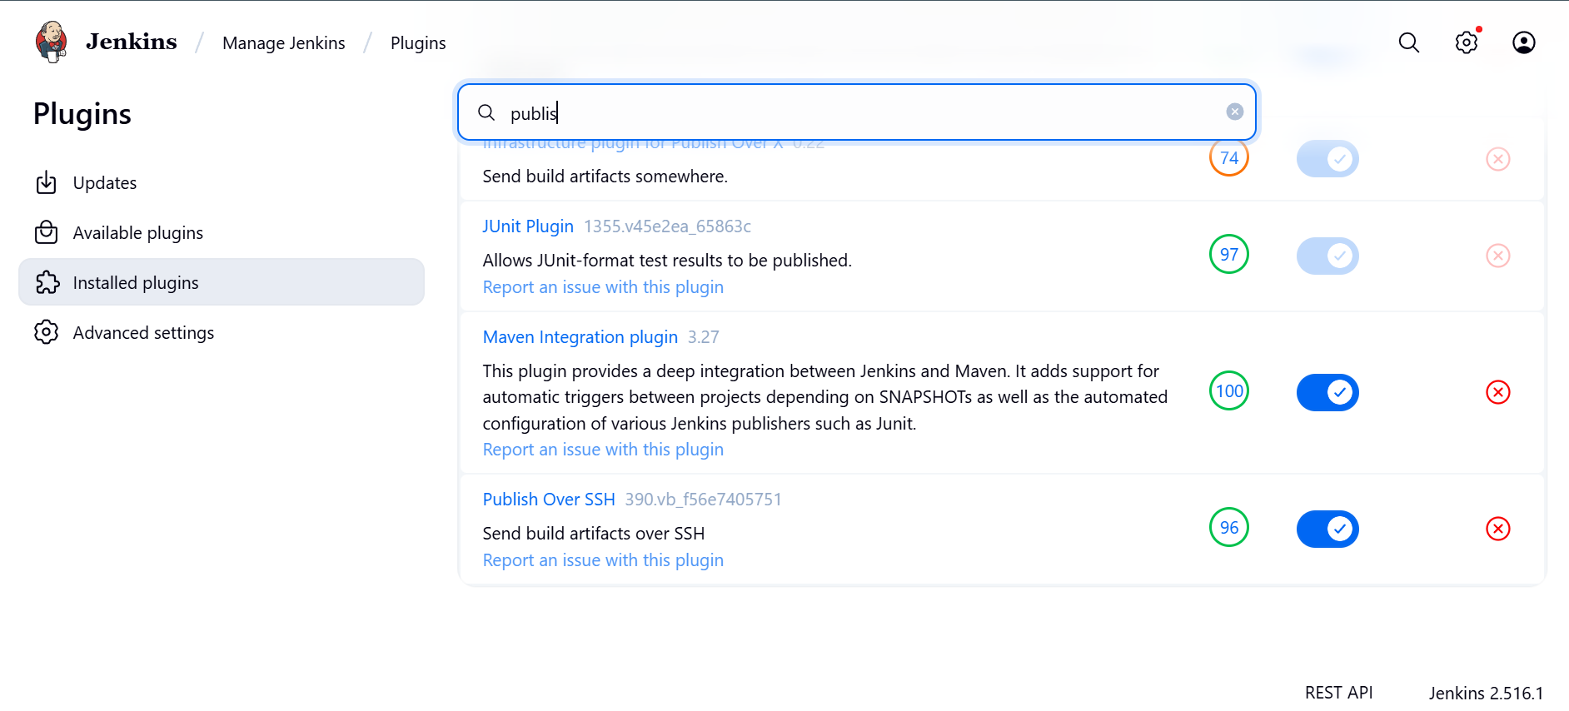

Step -3 go to Tools and configure the maven tool

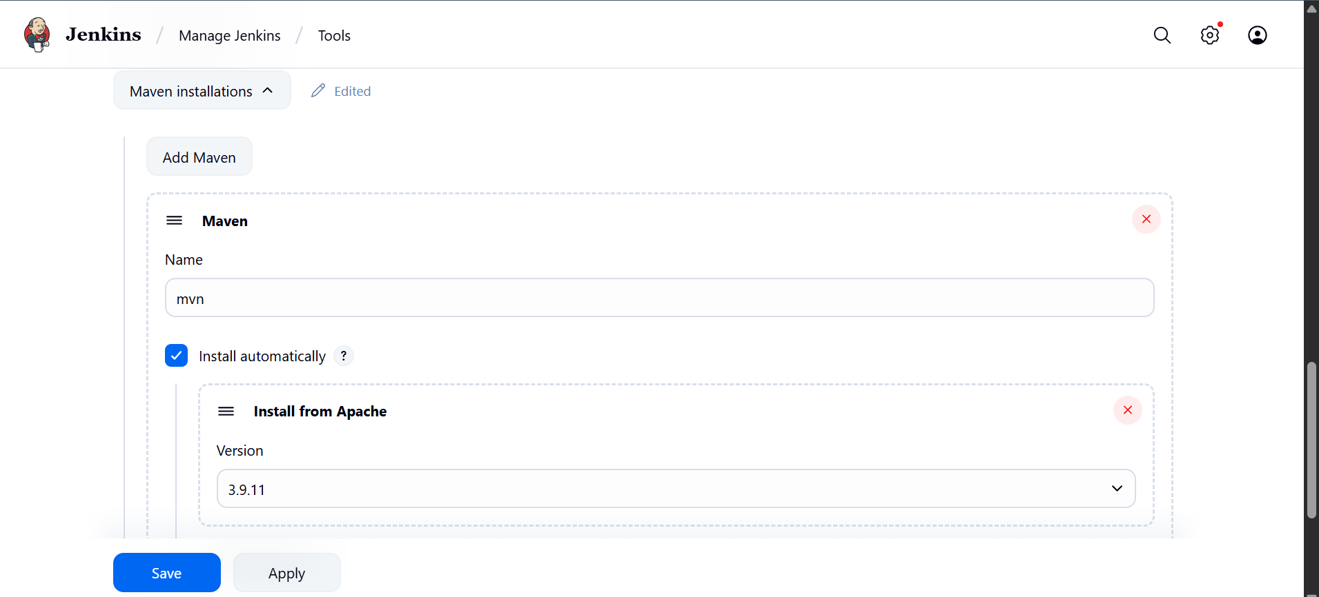

Step -4 go to system and configure ssh settings there you have to add the pvt key of tomcat instance

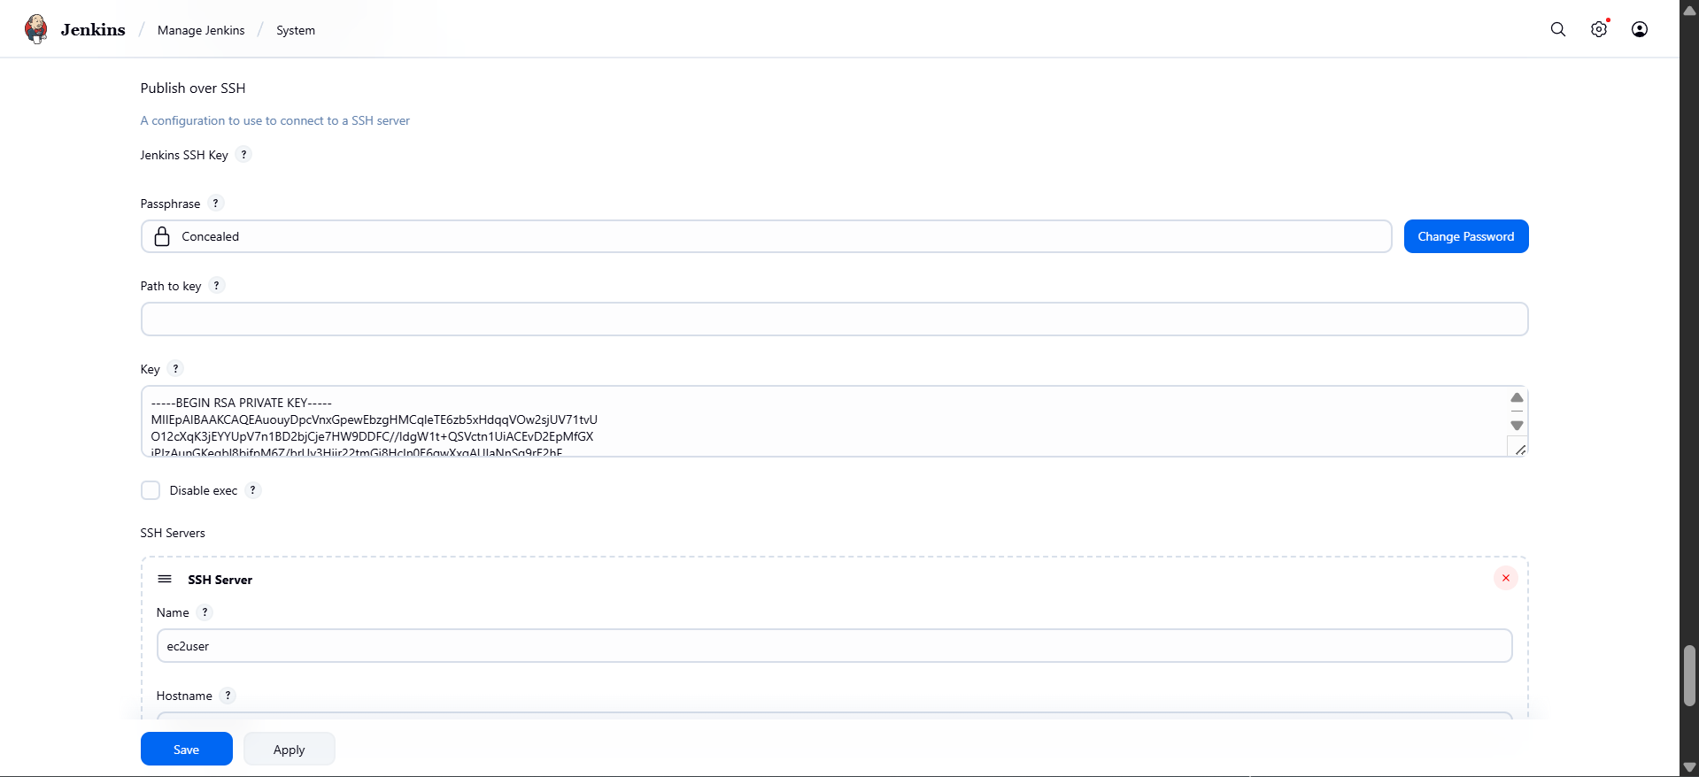

Step -5 Create a freestyle job with desired name and configure it

Choose discard old build set up the count according to the need

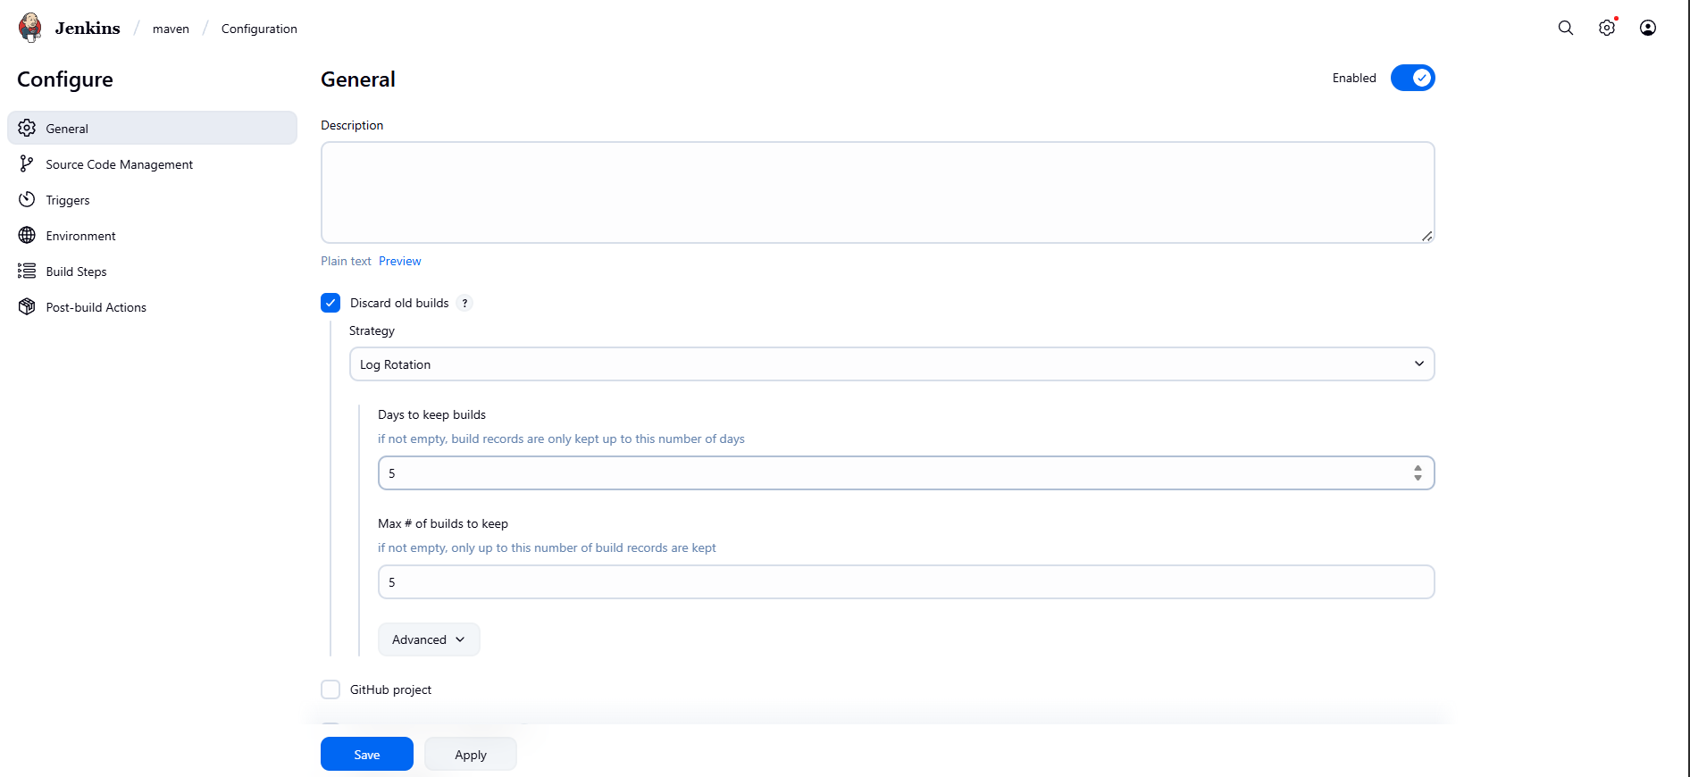

Select Git as SCM and add repo to that

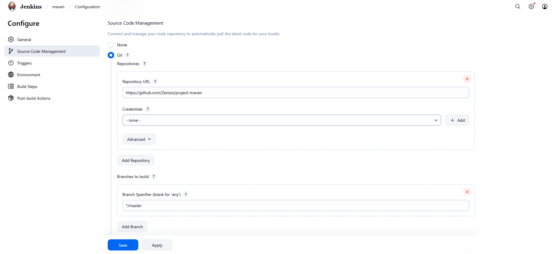

Go to the build step and Select top level maven target

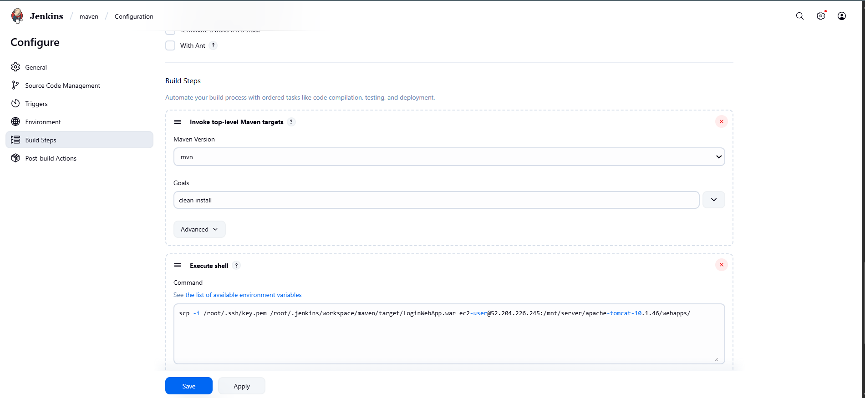

And add a build step to do scp the scp command will send the war file from Jenkins server to tomcat server

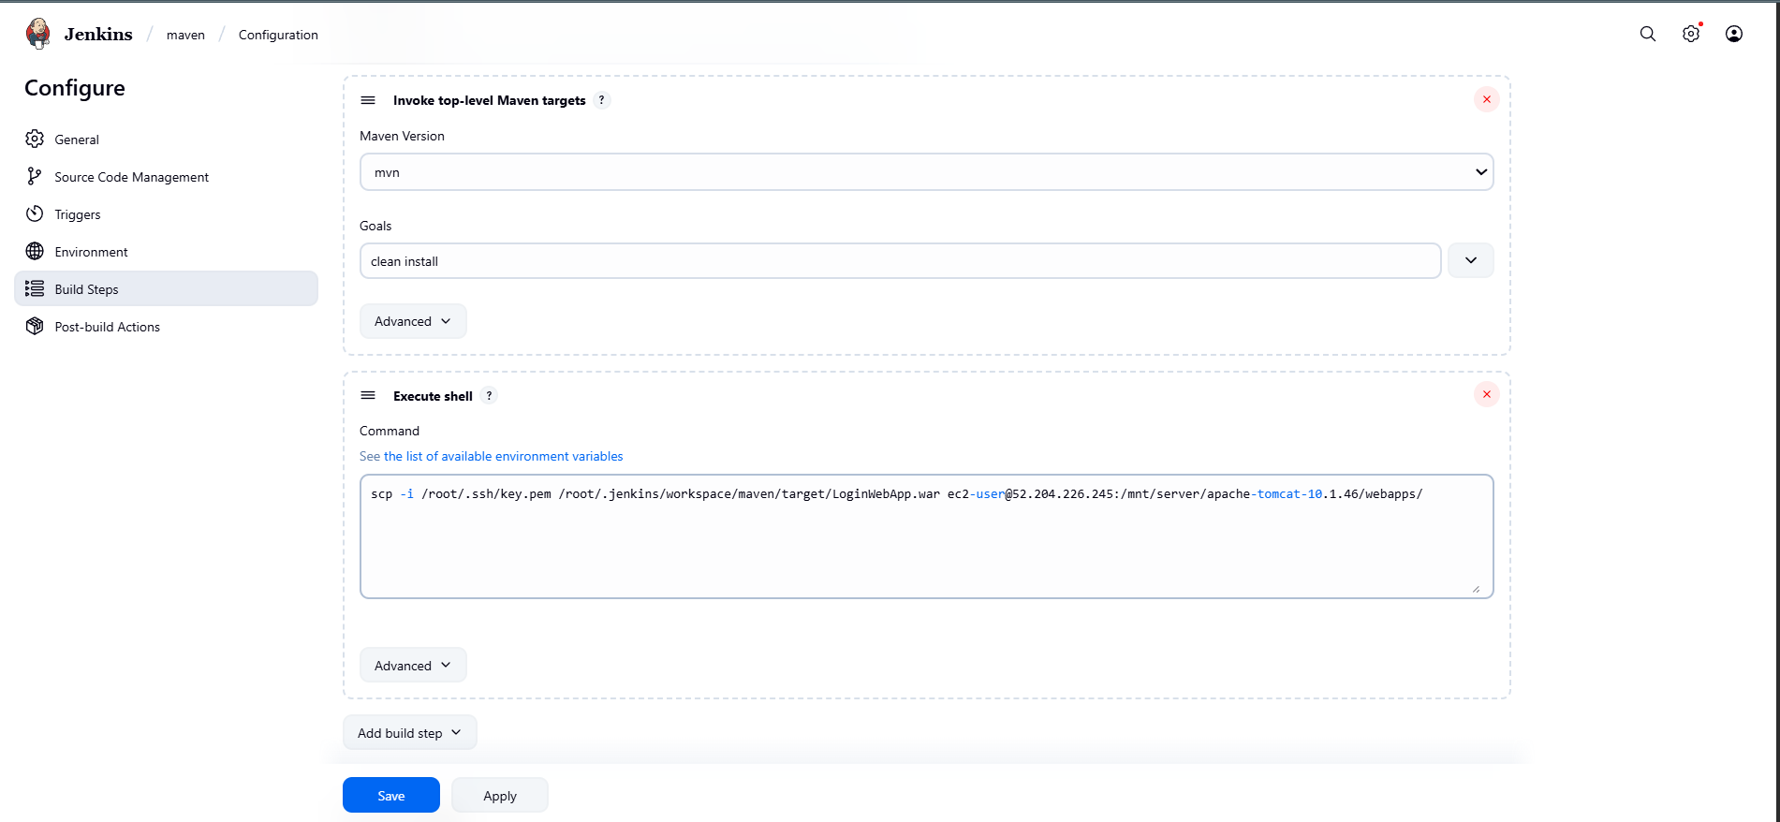

Step-6 Run the build and check output console for logs

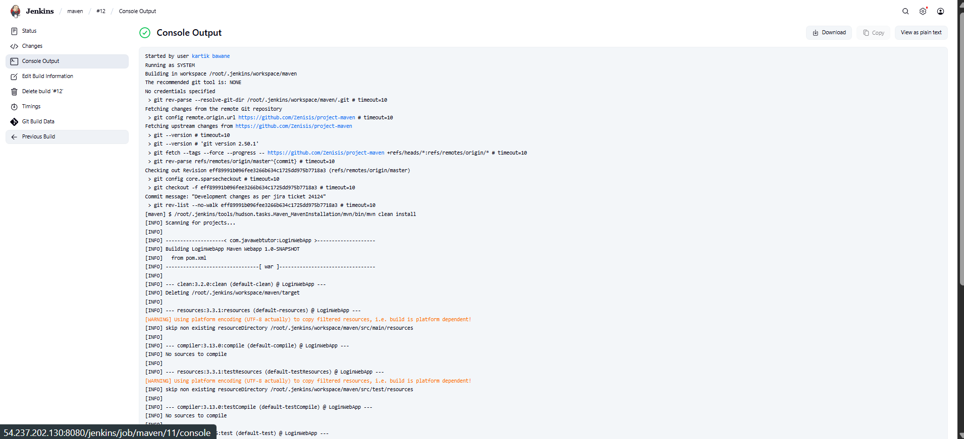

Here we can see the build is successful and the war application is running on tomcat server

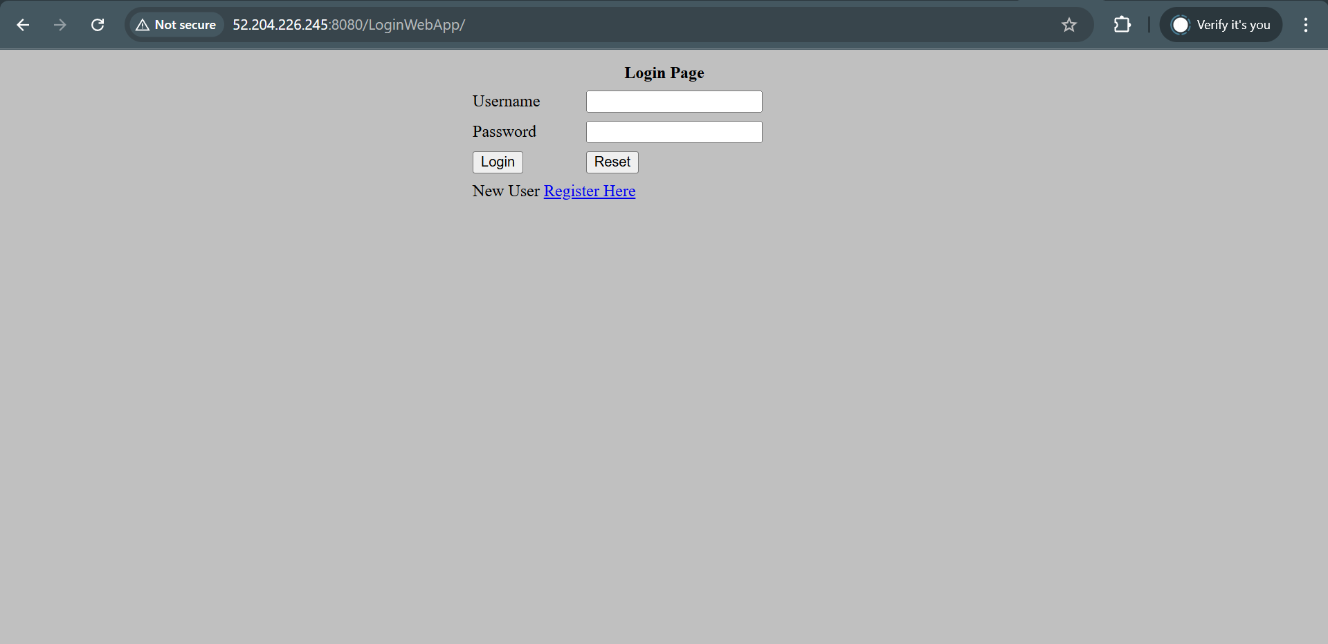

The application is been deployed using scp protocal